Attachment #1 - Examples of multiple billings. Again this is but a minute sample of what is available.
Row E is the Member identifier.
Row H is the date of service.
Row J is the diagnosis code.
Row K is the diagnosis.
It is quite easy to identify multiple billings for the same patient on the same day with 2 to 25 plus billings. The shell company sends the bill for the real or fictitious patient to Trillium Health the cordinated care organization (CCO) who pays the bills meaning the money ends up back in the parent companies pocket.
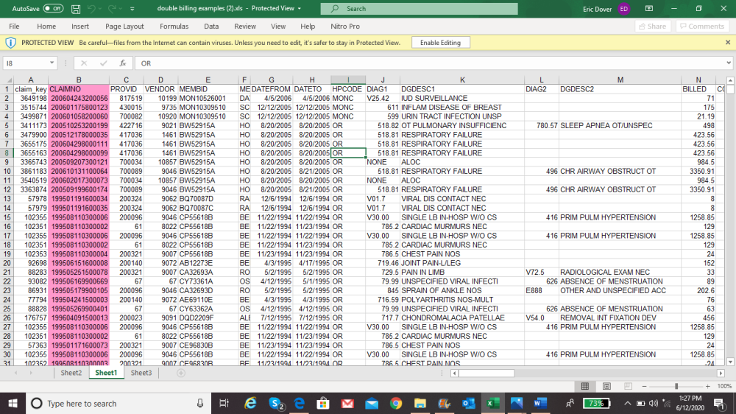

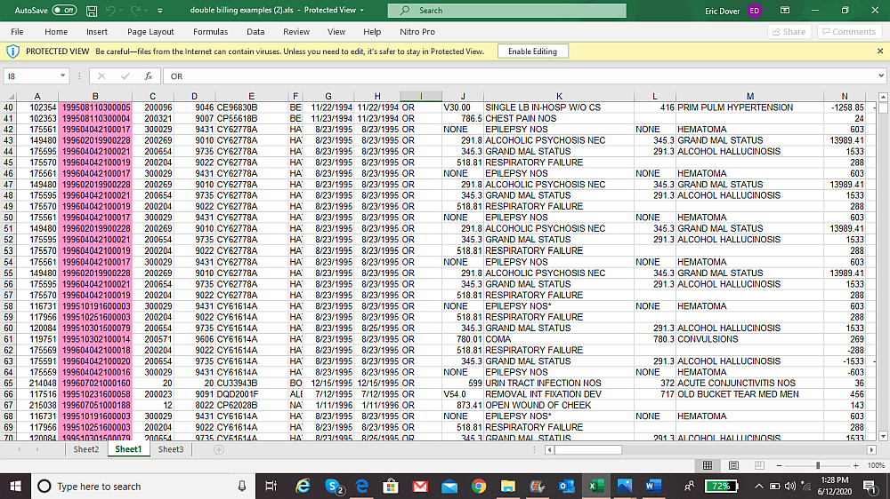
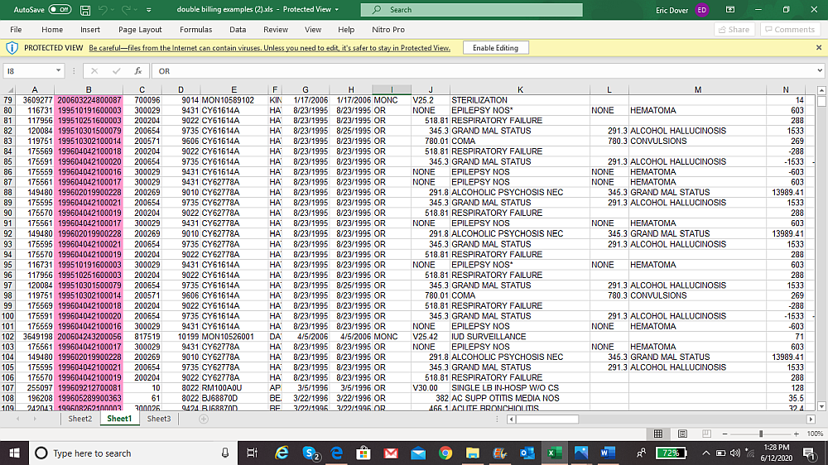

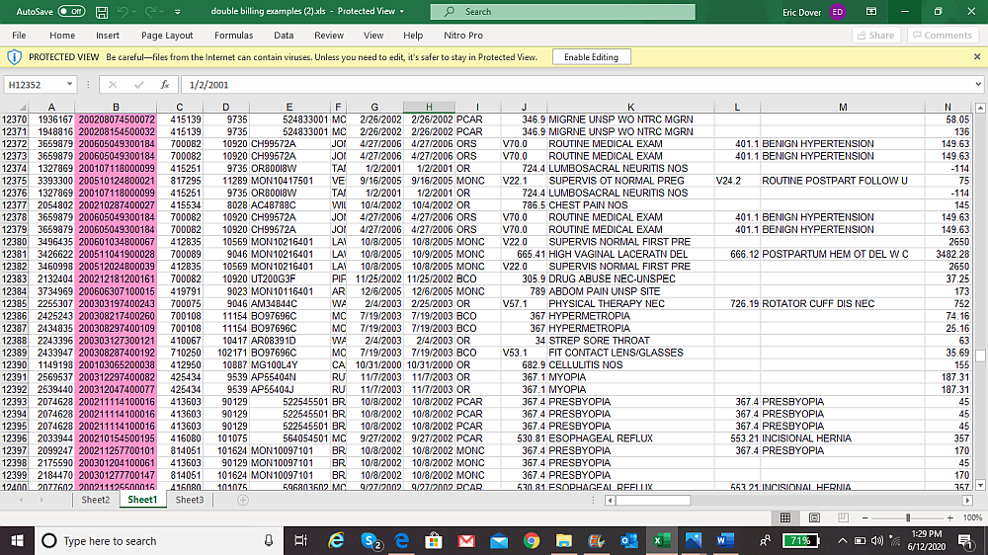
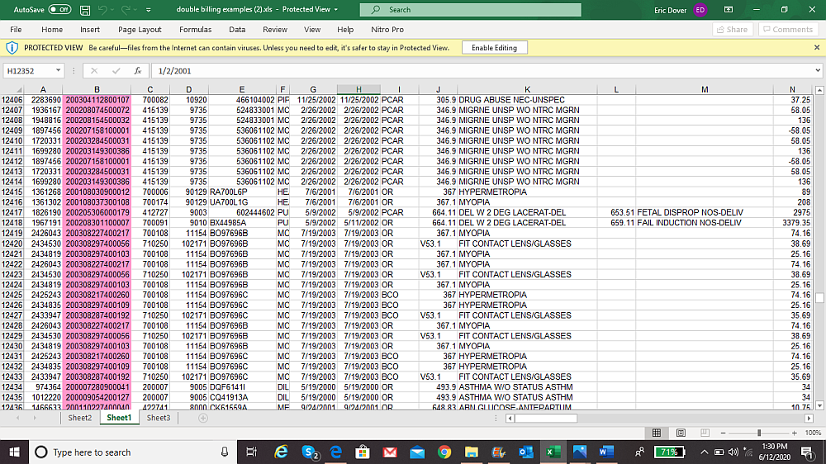

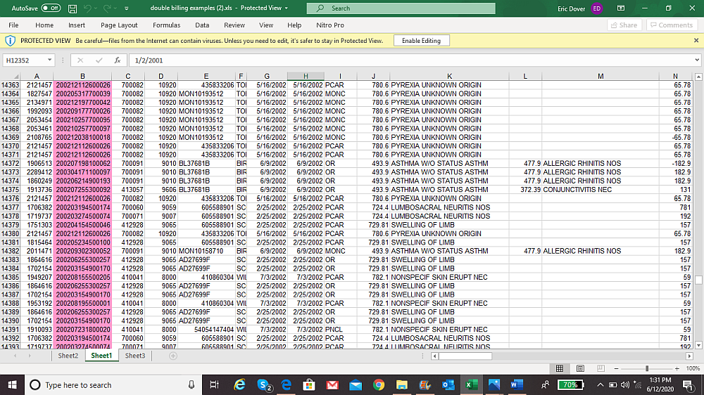
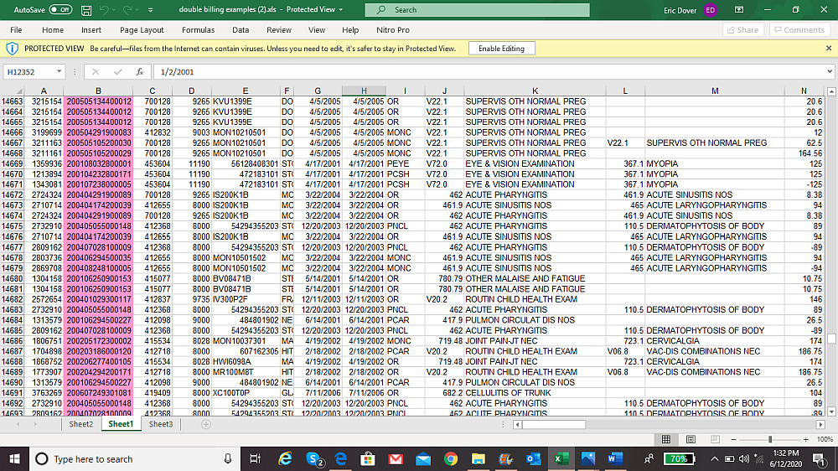
These are billings for the RSV (respiratory syncytial virus) vaccine. It is only supposed to be given once a year as soon as RSV breaks out in children who have compromised lungs. Typically it is a one time shot until these kid's lungs mature. Some will need it a year or two more.

Row F is the patient identifier.
Row O is the date of the injection.
Row V is the diagnosis code.
Row W is the diagnosis.

It is easy to see that multiple shots were given on the same day or days/weeks/months apart. These shots are NEVER administered this way - this is contradicted. Each shot is billed for. Pay close attention to the patiebt identifier to follow the fraud. According to the whistleblower every member number he checked into was fictitious. Again, the billing was done by a shell company of the parent company. Trillium Health the CCO (cordinated care organization) paid the bill and the money ended up in the parent company's pocket.



